**DAILY ONLINE ACTIVITIES SUMMARY**

|  |  |  |  |  |  |  |  |  |
| --- | --- | --- | --- | --- | --- | --- | --- | --- |
| **Date:** | **04/07/2020** | | | | | **Name:** | **Katira Krishna J** | |
| **Sem & Sec** | **8th A** | | | | | **USN:** | **4AL16CS045** | |
| **Online Test Summary** | | | | | | | | |
| **Subject** | | **-** | | | | | | |
| **Max. Marks** | | **-** | | **Score** | | | **-** | |
| **Certification Course Summary** | | | | | | | | |
| **Course** | **Accelerating Deep Learning with GPU** | | | | | | | |
| **Certificate Provider** | | | **Cognitiveclass.ai** | | **Duration** | | | **5 hours** |
| **Coding Challenges** | | | | | | | | |
| **Problem Statement: Python program to create class that performs basic calculator operations** | | | | | | | | |
| **Status: Completed** | | | | | | | | |
| **Uploaded the report in Github** | | | | | **Yes** | | | |
| **If yes Repository name** | | | | | **Krishna_Katira** | | | |
| **Uploaded the report in slack** | | | | | **Yes** | | | |

Online Test Details:

No test conducted

Certification Course Details:

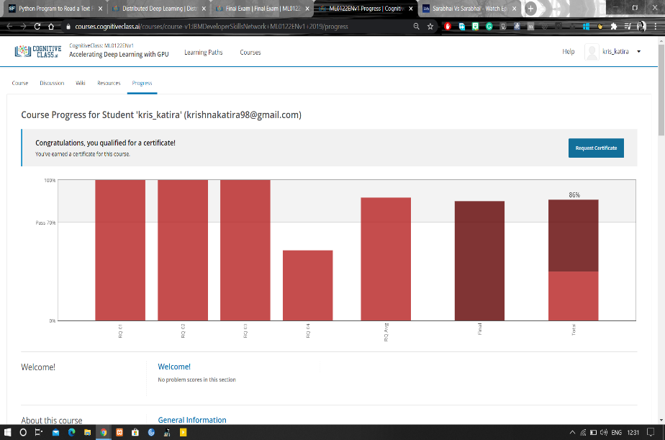

Coding Challenges Details:

**Program:**

class cal():

def __init__(self,a,b):

self.a=a

self.b=b

def add(self):

return self.a+self.b

def mul(self):

return self.a*self.b

def div(self):

return self.a/self.b

def sub(self):

return self.a-self.b

a=int(input("Enter first number: "))

b=int(input("Enter second number: "))

obj=cal(a,b)

choice=1

while choice!=0:

print("0. Exit")

print("1. Add")

print("2. Subtraction")

print("3. Multiplication")

print("4. Division")

choice=int(input("Enter choice: "))

if choice==1:

print("Result: ",obj.add())

elif choice==2:

print("Result: ",obj.sub())

elif choice==3:

print("Result: ",obj.mul())

elif choice==4:

print("Result: ",round(obj.div(),2))

elif choice==0:

print("Exiting!")

else:

print("Invalid choice!!")

print()